**Лабораторна робота № 27 «Робота в Spring Boot з різними типами баз даних»**

У цій роботі показано, як створити програму  **Spring Boot & JPA** використовуючи різні  **DataSource** . Щоб практикувати з прикладом, у нас є 2 бази даних:

* **PUBLISHER** : Це база даних 1, яка має таблицю PUBLISHERS.
* **ADVERTISER** : Це база даних 2, яка має таблицю ADVERTISERS.

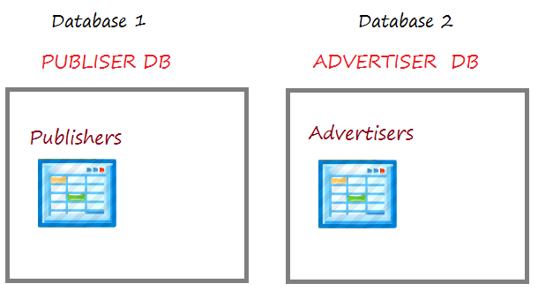

У цьому додатку функції (Сторінки) можуть використовувати одночасно обидві вищезгадані бази даних. Наприклад, одна сторінка відображає список видавців (Publisher), в той же час відображає рекламодавців (Advertiser), таким чином, вам потрібно працювати одночасно з 2 базами даних згадані вище.

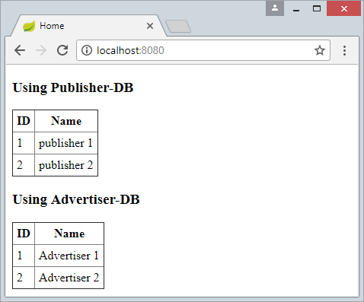

В іншому випадку, якщо вашому додатку потрібно кілька  **DataSource** , але кожна функція (кожна сторінка) працює тільки з одним певним  **DataSource** , вам варто використовувати **Routing DataSource** & **DataSource Interceptor** .

1. **Routing DataSource** є особливим  **DataSource** , він містить список реальних  **DataSource,**  які будуть використовуватися у вашому додатку.
2. **DataSource Interceptor** вирішує, який  **DataSource**  буде використаний відповідно з кожною функцією (кожною сторінкою) у вашому додатку.

* [Використовуйте декілька DataSource з Spring Boot та RoutingDataSource](https://betacode.net/10869/use-multiple-datasources-with-spring-boot-and-routingdatasource)

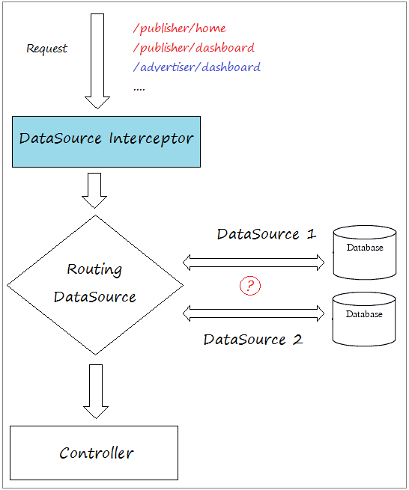

## 2- Приготувати Database

MySQL, SQL Server, PostGres

-- ===========================================

-- DATABASE FOR PUBLISHER SYSTEM

-- ===========================================

**create** **table** PUBLISHERS

(

ID Bigint,

NAME VARCHAR(255),

**Primary** key (ID)

);

**insert** **into** publishers (ID, NAME)

**values** (1, 'publisher 1');

**insert** **into** publishers (ID, NAME)

**values** (2, 'publisher 2');

-- ===========================================

-- DATABASE FOR ADVERTISER SYSTEM

-- ===========================================

**create** **table** ADVERTISERS

(

ID Bigint,

NAME VARCHAR(255),

**Primary** key (ID)

);

**insert** **into** advertisers (ID, NAME)

**values** (1, 'Advertiser 1');

**insert** **into** advertisers (ID, NAME)

**values** (2, 'Advertiser 2');

Oracle

-- ===========================================

-- DATABASE FOR PUBLISHER SYSTEM

-- ===========================================

**create** **table** PUBLISHERS

(

ID NUMBER(19),

NAME VARCHAR(255),

**Primary** key (ID)

);

**insert** **into** publishers (ID, NAME)

**values** (1, 'publisher 1');

**insert** **into** publishers (ID, NAME)

**values** (2, 'publisher 2');

**Commit**;

-- ===========================================

-- DATABASE FOR ADVERTISER SYSTEM

-- ===========================================

**create** **table** ADVERTISERS

(

ID NUMBER(19),

NAME VARCHAR(255),

**Primary** key (ID)

);

**insert** **into** advertisers (ID, NAME)

**values** (1, 'Advertiser 1');

**insert** **into** advertisers (ID, NAME)

**values** (2, 'Advertiser 2');

**Commit**;

## 3- Створити проект Spring Boot

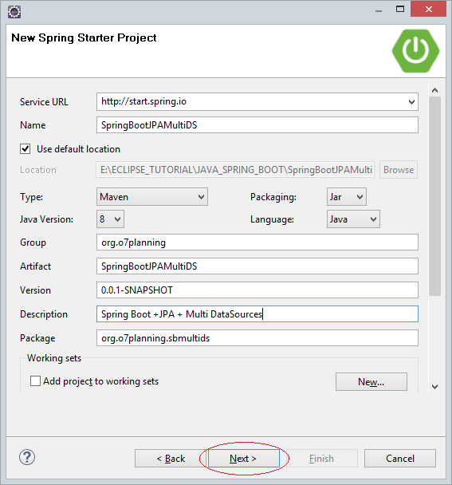

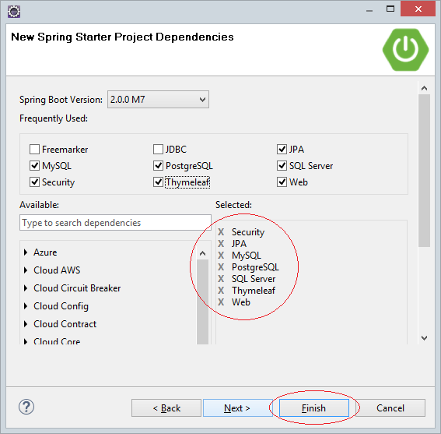

## 4- Конфігурація pom.xml

У файлі  **pom.xml** нижче, я вже конфігурував, щоб програма могла працювати з 4 видами поширених баз даних це  **MySQL, SQL Server, PostGres, Oracle** .

pom.xml

<?xml version="1.0" encoding="UTF-8"?>

<**project** xmlns="http://maven.apache.org/POM/4.0.0"

xmlns:xsi="http://www.w3.org/2001/XMLSchema-instance"

xsi:schemaLocation="http://maven.apache.org/POM/4.0.0

http://maven.apache.org/xsd/maven-4.0.0.xsd">

<**modelVersion**>4.0.0</**modelVersion**>

<**groupId**>org.o7planning</**groupId**>

<**artifactId**>SpringBootJPAMultiDS</**artifactId**>

<**version**>0.0.1-SNAPSHOT</**version**>

<**packaging**>jar</**packaging**>

<**name**>SpringBootJPAMultiDS</**name**>

<**description**>Spring Boot + JPA + Multiple DataSources</**description**>

<**parent**>

<**groupId**>org.springframework.boot</**groupId**>

<**artifactId**>spring-boot-starter-parent</**artifactId**>

<**version**>2.0.0.RELEASE</**version**>

<**relativePath**/> <!-- lookup parent from repository -->

</**parent**>

<**properties**>

<**project.build.sourceEncoding**>UTF-8</**project.build.sourceEncoding**>

<**project.reporting.outputEncoding**>UTF-8</**project.reporting.outputEncoding**>

<**java.version**>1.8</**java.version**>

</**properties**>

<**dependencies**>

<**dependency**>

<**groupId**>org.springframework.boot</**groupId**>

<**artifactId**>spring-boot-starter-data-jpa</**artifactId**>

</**dependency**>

<!-- Remove Thymeleaf, If you want using JSP View -->

<**dependency**>

<**groupId**>org.springframework.boot</**groupId**>

<**artifactId**>spring-boot-starter-thymeleaf</**artifactId**>

</**dependency**>

<**dependency**>

<**groupId**>org.springframework.boot</**groupId**>

<**artifactId**>spring-boot-starter-web</**artifactId**>

</**dependency**>

<**dependency**>

<**groupId**>mysql</**groupId**>

<**artifactId**>mysql-connector-java</**artifactId**>

<**scope**>runtime</**scope**>

</**dependency**>

<**dependency**>

<**groupId**>org.postgresql</**groupId**>

<**artifactId**>postgresql</**artifactId**>

<**scope**>runtime</**scope**>

</**dependency**>

<!-- SQL Server - Mssql-Jdbc driver -->

<**dependency**>

<**groupId**>com.microsoft.sqlserver</**groupId**>

<**artifactId**>mssql-jdbc</**artifactId**>

<**scope**>runtime</**scope**>

</**dependency**>

<!-- SQL Server - JTDS driver -->

<**dependency**>

<**groupId**>net.sourceforge.jtds</**groupId**>

<**artifactId**>jtds</**artifactId**>

<**scope**>runtime</**scope**>

</**dependency**>

<**dependency**>

<**groupId**>com.oracle</**groupId**>

<**artifactId**>ojdbc6</**artifactId**>

<**version**>11.2.0.3</**version**>

</**dependency**>

<!-- For JSP VIEW (Need REMOVE spring-boot-starter-thymeleaf) -->

<**dependency**>

<**groupId**>org.apache.tomcat.embed</**groupId**>

<**artifactId**>tomcat-embed-jasper</**artifactId**>

</**dependency**>

<!-- For JSP VIEW (Need REMOVE spring-boot-starter-thymeleaf) -->

<**dependency**>

<**groupId**>javax.servlet</**groupId**>

<**artifactId**>jstl</**artifactId**>

</**dependency**>

<**dependency**>

<**groupId**>org.springframework.boot</**groupId**>

<**artifactId**>spring-boot-starter-test</**artifactId**>

<**scope**>test</**scope**>

</**dependency**>

</**dependencies**>

<**repositories**>

<!-- Repository for ORACLE JDBC Driver -->

<**repository**>

<**id**>codelds</**id**>

<**url**>https://code.lds.org/nexus/content/groups/main-repo</**url**>

</**repository**>

</**repositories**>

<**build**>

<**plugins**>

<**plugin**>

<**groupId**>org.springframework.boot</**groupId**>

<**artifactId**>spring-boot-maven-plugin</**artifactId**>

</**plugin**>

</**plugins**>

</**build**>

</**project**>

## 5- Конфігурувати DataSource

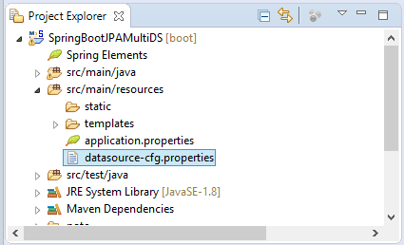

datasource-cfg.properties (MySQL)

# ===============================

# DATASOURCE

# ===============================

# DataSource (PUBLISHER System).

spring.datasource.driver-class-name.1=com.mysql.jdbc.Driver

spring.datasource.url.1=jdbc:mysql://localhost:3306/publisher

spring.datasource.username.1=root

spring.datasource.password.1=12345

# DataSource (ADVERTISER System).

spring.datasource.driver-class-name.2=com.mysql.jdbc.Driver

spring.datasource.url.2=jdbc:mysql://localhost:3306/advertiser

spring.datasource.username.2=root

spring.datasource.password.2=12345

# ===============================

# JPA / HIBERNATE

# ===============================

spring.jpa.show-sql.1=true

spring.jpa.hibernate.ddl-auto.1=none

spring.jpa.properties.hibernate.dialect.1=org.hibernate.dialect.MySQLDialect

#spring.jpa.properties.hibernate.current_session_context_class.1=org.springframework.orm.hibernate5.SpringSessionContext

spring.jpa.show-sql.2=true

spring.jpa.hibernate.ddl-auto.2=none

spring.jpa.properties.hibernate.dialect.2=org.hibernate.dialect.MySQLDialect

#spring.jpa.properties.hibernate.current_session_context_class.2=org.springframework.orm.hibernate5.SpringSessionContext

datasource-cfg.properties (SQL Server + JTDS Driver)

# ===============================

# DATASOURCE

# ===============================

# DataSource (PUBLISHER System).

spring.datasource.driver-class-name.1=net.sourceforge.jtds.jdbc.Driver

spring.datasource.url.1=jdbc:jtds:sqlserver://localhost:1433/publisher;instance=SQLEXPRESS

spring.datasource.username.1=sa

spring.datasource.password.1=12345

# DataSource (ADVERTISER System).

spring.datasource.driver-class-name.2=net.sourceforge.jtds.jdbc.Driver

spring.datasource.url.2=jdbc:jtds:sqlserver://localhost:1433/advertiser;instance=SQLEXPRESS

spring.datasource.username.2=sa

spring.datasource.password.2=12345

# ===============================

# JPA / HIBERNATE

# ===============================

spring.jpa.show-sql.1=true

spring.jpa.hibernate.ddl-auto.1=none

spring.jpa.properties.hibernate.dialect.1=org.hibernate.dialect.SQLServerDialect

#spring.jpa.properties.hibernate.current_session_context_class.1=org.springframework.orm.hibernate5.SpringSessionContext

spring.jpa.show-sql.2=true

spring.jpa.hibernate.ddl-auto.2=none

spring.jpa.properties.hibernate.dialect.2=org.hibernate.dialect.SQLServerDialect

#spring.jpa.properties.hibernate.current_session_context_class.2=org.springframework.orm.hibernate5.SpringSessionContext

datasource-cfg.properties (SQL Server + Mssql-Jdbc Driver)

# ===============================

# DATASOURCE

# ===============================

# DataSource (PUBLISHER System).

spring.datasource.driver-class-name.1=com.microsoft.sqlserver.jdbc.SQLServerDriver

spring.datasource.url.1=jdbc:sqlserver://tran-vmware-pc\\SQLEXPRESS:1433;databaseName=publisher

spring.datasource.username.1=sa

spring.datasource.password.1=12345

# DataSource (ADVERTISER System).

spring.datasource.driver-class-name.2=com.microsoft.sqlserver.jdbc.SQLServerDriver

spring.datasource.url.2=jdbc:sqlserver://tran-vmware-pc\\SQLEXPRESS:1433;databaseName=advertiser

spring.datasource.username.2=sa

spring.datasource.password.2=12345

# ===============================

# JPA / HIBERNATE

# ===============================

spring.jpa.show-sql.1=true

spring.jpa.hibernate.ddl-auto.1=none

spring.jpa.properties.hibernate.dialect.1=org.hibernate.dialect.SQLServerDialect

#spring.jpa.properties.hibernate.current_session_context_class.1=org.springframework.orm.hibernate5.SpringSessionContext

spring.jpa.show-sql.2=true

spring.jpa.hibernate.ddl-auto.2=none

spring.jpa.properties.hibernate.dialect.2=org.hibernate.dialect.SQLServerDialect

#spring.jpa.properties.hibernate.current_session_context_class.2=org.springframework.orm.hibernate5.SpringSessionContext

datasource-cfg.properties (Oracle)

# ===============================

# DATASOURCE

# ===============================

# DataSource (PUBLISHER System).

spring.datasource.driver-class-name.1=oracle.jdbc.driver.OracleDriver

spring.datasource.url.1=jdbc:oracle:thin:@localhost:1521:db12c

spring.datasource.username.1=publisher

spring.datasource.password.1=12345

# DataSource (ADVERTISER System).

spring.datasource.driver-class-name.2=oracle.jdbc.driver.OracleDriver

spring.datasource.url.2=jdbc:oracle:thin:@localhost:1521:db12c

spring.datasource.username.2=advertiser

spring.datasource.password.2=12345

# ===============================

# JPA / HIBERNATE

# ===============================

spring.jpa.show-sql.1=true

spring.jpa.hibernate.ddl-auto.1=none

spring.jpa.properties.hibernate.dialect.1=org.hibernate.dialect.Oracle10gDialect

#spring.jpa.properties.hibernate.current_session_context_class.1=org.springframework.orm.hibernate5.SpringSessionContext

spring.jpa.show-sql.2=true

spring.jpa.hibernate.ddl-auto.2=none

spring.jpa.properties.hibernate.dialect.2=org.hibernate.dialect.Oracle10gDialect

#spring.jpa.properties.hibernate.current_session_context_class.2=org.springframework.orm.hibernate5.SpringSessionConte

datasource-cfg.properties (PostGres)

# ===============================

# DATASOURCE

# ===============================

# DataSource (PUBLISHER System).

spring.datasource.driver-class-name.1=org.postgresql.Driver

spring.datasource.url.1=jdbc:postgresql://tran-vmware-pc:5432/publisher

spring.datasource.username.1=postgres

spring.datasource.password.1=12345

# DataSource (ADVERTISER System).

spring.datasource.driver-class-name.2=org.postgresql.Driver

spring.datasource.url.2=jdbc:postgresql://tran-vmware-pc:5432/advertiser

spring.datasource.username.2=postgres

spring.datasource.password.2=12345

# ===============================

# JPA / HIBERNATE

# ===============================

spring.jpa.show-sql.1=true

spring.jpa.hibernate.ddl-auto.1=none

spring.jpa.properties.hibernate.dialect.1=org.hibernate.dialect.PostgreSQL9Dialect

#spring.jpa.properties.hibernate.current_session_context_class.1=org.springframework.orm.hibernate5.SpringSessionContext

spring.jpa.show-sql.2=true

spring.jpa.hibernate.ddl-auto.2=none

spring.jpa.properties.hibernate.dialect.2=org.hibernate.dialect.PostgreSQL9Dialect

#spring.jpa.properties.hibernate.current_session_context_class.2=org.springframework.orm.hibernate5.SpringSessionContext

За промовчанням  **Spring Boot** автоматично конфігурує  **DataSource** за замовчуванням, тому вам потрібно вимкнути цю автоматичну конфігурацію у  **Spring Boot** , і конфігурувати окремий  **DataSource** вручну.

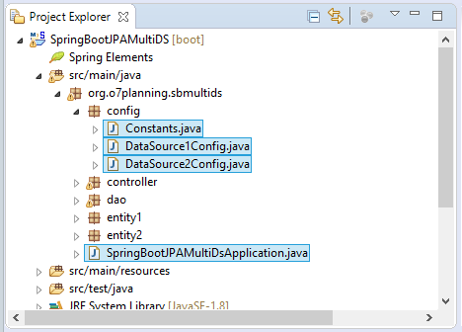

SpringBootJPAMultiDsApplication.java

**package** org.o7planning.sbmultids;

**import** org.springframework.boot.SpringApplication;

**import** org.springframework.boot.autoconfigure.EnableAutoConfiguration;

**import** org.springframework.boot.autoconfigure.SpringBootApplication;

**import** org.springframework.boot.autoconfigure.jdbc.DataSourceAutoConfiguration;

**import** org.springframework.boot.autoconfigure.jdbc.DataSourceTransactionManagerAutoConfiguration;

**import** org.springframework.boot.autoconfigure.orm.jpa.HibernateJpaAutoConfiguration;

@SpringBootApplication

// Disable some Spring Boot auto config

@EnableAutoConfiguration(exclude = { //

DataSourceAutoConfiguration.class, //

DataSourceTransactionManagerAutoConfiguration.class, //

HibernateJpaAutoConfiguration.class })

**public** **class** **SpringBootJPAMultiDsApplication** {

**public** **static** **void** **main**(String[] args) {

SpringApplication.run(SpringBootJPAMultiDsApplication.class, args);

}

}

Далі ми конфігуруємо 2 **DataSource** :

1. Клас  **DataSource1Config**  використовується для конфігурації datasource 1 (PUBLISHER DB).
2. Клас  **DataSource2Config** використовується для конфігурації datasource datasource 2 (ADVERTISER DB).

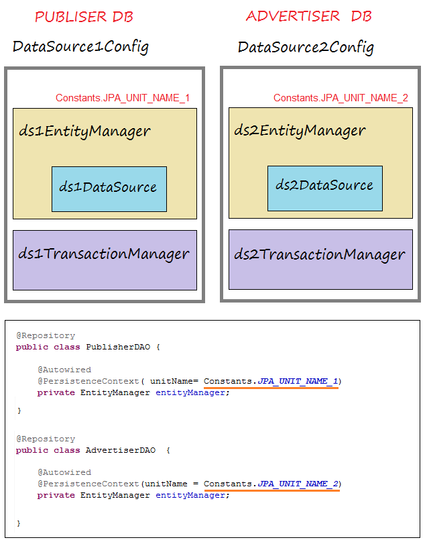

Constants.java

**package** org.o7planning.sbmultids.config;

**public** **class** **Constants** {

**public** **static** **final** String PACKAGE_ENTITIES_1 = "org.o7planning.sbmultids.entity1";

**public** **static** **final** String PACKAGE_ENTITIES_2 = "org.o7planning.sbmultids.entity2";

**public** **static** **final** String JPA_UNIT_NAME_1 ="PERSITENCE_UNIT_NAME_1";

**public** **static** **final** String JPA_UNIT_NAME_2 ="PERSITENCE_UNIT_NAME_2";

}

DataSource1Config.java

**package** org.o7planning.sbmultids.config;

**import** java.util.HashMap;

**import** javax.sql.DataSource;

**import** org.springframework.beans.factory.annotation.Autowired;

**import** org.springframework.context.annotation.Bean;

**import** org.springframework.context.annotation.Configuration;

**import** org.springframework.context.annotation.PropertySource;

**import** org.springframework.context.annotation.PropertySources;

**import** org.springframework.core.env.Environment;

**import** org.springframework.jdbc.datasource.DriverManagerDataSource;

**import** org.springframework.orm.jpa.JpaTransactionManager;

**import** org.springframework.orm.jpa.LocalContainerEntityManagerFactoryBean;

**import** org.springframework.orm.jpa.vendor.HibernateJpaVendorAdapter;

**import** org.springframework.transaction.PlatformTransactionManager;

@Configuration

// Load to Environment

// (@see resources/datasource-cfg.properties).

@PropertySources({ @PropertySource("classpath:datasource-cfg.properties") })

**public** **class** **DataSource1Config** {

@Autowired

**private** Environment env; // Contains Properties Load by @PropertySources

@Bean

**public** DataSource **ds1Datasource**() {

DriverManagerDataSource dataSource = **new** **DriverManagerDataSource**();

dataSource.setDriverClassName(env.getProperty("spring.datasource.driver-class-name.1"));

dataSource.setUrl(env.getProperty("spring.datasource.url.1"));

dataSource.setUsername(env.getProperty("spring.datasource.username.1"));

dataSource.setPassword(env.getProperty("spring.datasource.password.1"));

**return** dataSource;

}

@Bean

**public** LocalContainerEntityManagerFactoryBean **ds1EntityManager**() {

LocalContainerEntityManagerFactoryBean em = **new** **LocalContainerEntityManagerFactoryBean**();

em.setDataSource(ds1Datasource());

// Scan Entities in Package:

em.setPackagesToScan(**new** **String**[] { Constants.PACKAGE_ENTITIES_1 });

em.setPersistenceUnitName(Constants.JPA_UNIT_NAME_1); // Important !!

//

HibernateJpaVendorAdapter vendorAdapter = **new** **HibernateJpaVendorAdapter**();

em.setJpaVendorAdapter(vendorAdapter);

HashMap<String, Object> properties = **new** **HashMap**<>();

// JPA & Hibernate

properties.put("hibernate.dialect", env.getProperty("spring.jpa.properties.hibernate.dialect.1"));

properties.put("hibernate.show-sql", env.getProperty("spring.jpa.show-sql.1"));

// Solved Error: PostGres createClob() is not yet implemented.

// PostGres Only:

// properties.put("hibernate.temp.use_jdbc_metadata_defaults", false);

em.setJpaPropertyMap(properties);

em.afterPropertiesSet();

**return** em;

}

@Bean

**public** PlatformTransactionManager **ds1TransactionManager**() {

JpaTransactionManager transactionManager = **new** **JpaTransactionManager**();

transactionManager.setEntityManagerFactory(ds1EntityManager().getObject());

**return** transactionManager;

}

}

DataSource2Config.java

**package** org.o7planning.sbmultids.config;

**import** java.util.HashMap;

**import** javax.sql.DataSource;

**import** org.springframework.beans.factory.annotation.Autowired;

**import** org.springframework.context.annotation.Bean;

**import** org.springframework.context.annotation.Configuration;

**import** org.springframework.context.annotation.PropertySource;

**import** org.springframework.context.annotation.PropertySources;

**import** org.springframework.core.env.Environment;

**import** org.springframework.jdbc.datasource.DriverManagerDataSource;

**import** org.springframework.orm.jpa.JpaTransactionManager;

**import** org.springframework.orm.jpa.LocalContainerEntityManagerFactoryBean;

**import** org.springframework.orm.jpa.vendor.HibernateJpaVendorAdapter;

**import** org.springframework.transaction.PlatformTransactionManager;

@Configuration

// Load to Environment

// (@see resources/datasource-cfg.properties).

@PropertySources({ @PropertySource("classpath:datasource-cfg.properties") })

**public** **class** **DataSource2Config** {

@Autowired

**private** Environment env; // Contains Properties Load by @PropertySources

@Bean

**public** DataSource **ds2Datasource**() {

DriverManagerDataSource dataSource = **new** **DriverManagerDataSource**();

dataSource.setDriverClassName(env.getProperty("spring.datasource.driver-class-name.2"));

dataSource.setUrl(env.getProperty("spring.datasource.url.2"));

dataSource.setUsername(env.getProperty("spring.datasource.username.2"));

dataSource.setPassword(env.getProperty("spring.datasource.password.2"));

**return** dataSource;

}

@Bean

**public** LocalContainerEntityManagerFactoryBean **ds2EntityManager**() {

LocalContainerEntityManagerFactoryBean em = **new** **LocalContainerEntityManagerFactoryBean**();

em.setDataSource(ds2Datasource());

// Scan Entities in Package:

em.setPackagesToScan(**new** **String**[] { Constants.PACKAGE_ENTITIES_2 });

em.setPersistenceUnitName(Constants.JPA_UNIT_NAME_2);

HibernateJpaVendorAdapter vendorAdapter = **new** **HibernateJpaVendorAdapter**();

em.setJpaVendorAdapter(vendorAdapter);

HashMap<String, Object> properties = **new** **HashMap**<>();

// JPA & Hibernate

properties.put("hibernate.dialect", env.getProperty("spring.jpa.properties.hibernate.dialect.2"));

properties.put("hibernate.show-sql", env.getProperty("spring.jpa.show-sql.2"));

// Solved Error: PostGres createClob() is not yet implemented.

// PostGres Only.

// properties.put("hibernate.temp.use_jdbc_metadata_defaults", false);

em.setJpaPropertyMap(properties);

em.afterPropertiesSet();

**return** em;

}

@Bean

**public** PlatformTransactionManager **ds2TransactionManager**() {

JpaTransactionManager transactionManager = **new** **JpaTransactionManager**();

transactionManager.setEntityManagerFactory(ds2EntityManager().getObject());

**return** transactionManager;

}

}

## 6- Entities, DAO

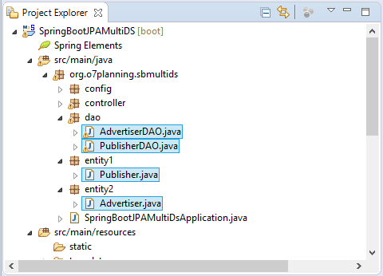

Publisher.java

**package** org.o7planning.sbmultids.entity1;

**import** java.io.Serializable;

**import** javax.persistence.Column;

**import** javax.persistence.Entity;

**import** javax.persistence.GeneratedValue;

**import** javax.persistence.Id;

**import** javax.persistence.Table;

@Entity

@Table(name = "Publishers")

**public** **class** **Publisher** **implements** **Serializable** {

**private** **static** **final** long serialVersionUID = 746237126088051312L;

@Id

@GeneratedValue

@Column(name = "Id")

**private** Long id;

@Column(name = "Name", length = 255, nullable = false)

**private** String name;

**public** Long **getId**() {

**return** id;

}

**public** **void** **setId**(Long id) {

this.id = id;

}

**public** String **getName**() {

**return** name;

}

**public** **void** **setName**(String name) {

this.name = name;

}

}

Advertiser.java

**package** org.o7planning.sbmultids.entity2;

**import** java.io.Serializable;

**import** javax.persistence.Column;

**import** javax.persistence.Entity;

**import** javax.persistence.GeneratedValue;

**import** javax.persistence.Id;

**import** javax.persistence.Table;

@Entity

@Table(name = "Advertisers")

**public** **class** **Advertiser** **implements** **Serializable** {

**private** **static** **final** long serialVersionUID = 746237126088051312L;

@Id

@GeneratedValue

@Column(name = "Id")

**private** Long id;

@Column(name = "Name", length = 255, nullable = false)

**private** String name;

**public** Long **getId**() {

**return** id;

}

**public** **void** **setId**(Long id) {

this.id = id;

}

**public** String **getName**() {

**return** name;

}

**public** **void** **setName**(String name) {

this.name = name;

}

}

PublisherDAO.java

**package** org.o7planning.sbmultids.dao;

**import** java.util.List;

**import** javax.persistence.EntityManager;

**import** javax.persistence.PersistenceContext;

**import** javax.persistence.Query;

**import** org.o7planning.sbmultids.config.Constants;

**import** org.o7planning.sbmultids.entity1.Publisher;

**import** org.springframework.beans.factory.annotation.Autowired;

**import** org.springframework.stereotype.Repository;

@Repository

**public** **class** **PublisherDAO** {

@Autowired

@PersistenceContext( unitName= Constants.JPA_UNIT_NAME_1)

**private** EntityManager entityManager;

**public** List<Publisher> **listPublishers**() {

String sql = "Select e from " + Publisher.class.getName() + " e ";

Query query = entityManager.createQuery(sql, Publisher.class);

**return** query.getResultList();

}

**public** Publisher **findById**(Long id) {

**return** this.entityManager.find(Publisher.class, id);

}

}

AdvertiserDAO.java

**package** org.o7planning.sbmultids.dao;

**import** java.util.List;

**import** javax.persistence.EntityManager;

**import** javax.persistence.PersistenceContext;

**import** javax.persistence.Query;

**import** org.o7planning.sbmultids.config.Constants;

**import** org.o7planning.sbmultids.entity2.Advertiser;

**import** org.springframework.beans.factory.annotation.Autowired;

**import** org.springframework.stereotype.Repository;

@Repository

**public** **class** **AdvertiserDAO** {

@Autowired

@PersistenceContext(unitName = Constants.JPA_UNIT_NAME_2)

**private** EntityManager entityManager;

**public** List<Advertiser> **listAdvertisers**() {

String sql = "Select e from " + Advertiser.class.getName() + " e ";

Query query = entityManager.createQuery(sql, Advertiser.class);

**return** query.getResultList();

}

**public** Advertiser **findById**(Long id) {

**return** this.entityManager.find(Advertiser.class, id);

}

}

## 7- Controller

MainController.java

**package** org.o7planning.sbmultids.controller;

**import** java.util.List;

**import** org.o7planning.sbmultids.dao.AdvertiserDAO;

**import** org.o7planning.sbmultids.dao.PublisherDAO;

**import** org.o7planning.sbmultids.entity1.Publisher;

**import** org.o7planning.sbmultids.entity2.Advertiser;

**import** org.springframework.beans.factory.annotation.Autowired;

**import** org.springframework.stereotype.Controller;

**import** org.springframework.ui.Model;

**import** org.springframework.web.bind.annotation.RequestMapping;

**import** org.springframework.web.bind.annotation.RequestMethod;

@Controller

**public** **class** **MainController** {

@Autowired

**private** PublisherDAO publisherDAO;

@Autowired

**private** AdvertiserDAO advertiserDAO;

@RequestMapping(value = "/", method = RequestMethod.GET)

**public** String **homePage**(Model model) {

List<Advertiser> advertisers = advertiserDAO.listAdvertisers();

List<Publisher> publishers = publisherDAO.listPublishers();

model.addAttribute("advertisers", advertisers);

model.addAttribute("publishers", publishers);

**return** "home";

}

}

## 8- Thymeleaf Template

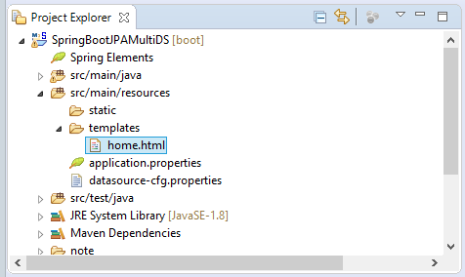

home.html

<!DOCTYPE **html**>

<**html** xmlns:th="http://www.thymeleaf.org">

<**head**>

<**meta** charset="UTF-8"/>

<**title**>Home</**title**>

<**style**>

**th**, **td** {

**padding**: 5px;

}

**table** {

**border-collapse**: collapse;

}

</**style**>

</**head**>

<**body**>

<**h3**>Using Publisher-DB</**h3**>

<**table** border="1">

<**tr**>

<**th**>ID</**th**>

<**th**>Name</**th**>

</**tr**>

<**tr** th:each="publisher : ${publishers}">

<**td** th:utext="${publisher.id}"></**td**>

<**td** th:utext="${publisher.name}"></**td**>

</**tr**>

</**table**>

<**h3**>Using Advertiser-DB</**h3**>

<**table** border="1">

<**tr**>

<**th**>ID</**th**>

<**th**>Name</**th**>

</**tr**>

<**tr** th:each="advertiser : ${advertisers}">

<**td** th:utext="${advertiser.id}"></**td**>

<**td** th:utext="${advertiser.name}"></**td**>

</**tr**>

</**table**>

</**body**>

</**html**>

## 9- Апендикс: JSP View

У випадку, якщо ви використовуєте технологію  **JSP** для рівня  **View** :

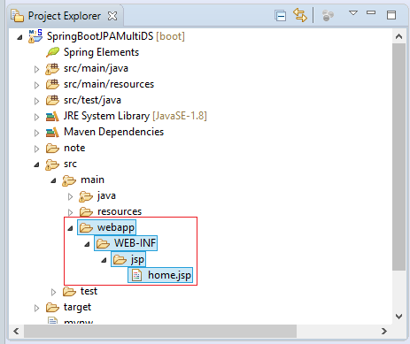

home.jsp

<%@ taglib uri="http://java.sun.com/jsp/jstl/core" prefix="c"%>

<%@ page contentType="text/html; charset=UTF-8" %>

<!DOCTYPE **html**>

<**html** xmlns:th="http://www.thymeleaf.org">

<**head**>

<**meta** charset="UTF-8"/>

<**title**>Home</**title**>

<**style**>

**th**, **td** {

**padding**: 5px;

}

**table** {

**border-collapse**: collapse;

}

</**style**>

</**head**>

<**body**>

<**h3**>Using Publisher-DB</**h3**>

<**table** border="1">

<**tr**>

<**th**>ID</**th**>

<**th**>Name</**th**>

</**tr**>

<**c:forEach** items="${publishers}" var="publisher">

<**tr**>

<**td** th:utext="${publisher.id}"></**td**>

<**td** th:utext="${publisher.name}"></**td**>

</**tr**>

</**c:forEach**>

</**table**>

<**h3**>Using Advertiser-DB</**h3**>

<**table** border="1">

<**tr**>

<**th**>ID</**th**>

<**th**>Name</**th**>

</**tr**>

<**c:forEach** items="${advertisers}" var="advertiser">

<**tr**>

<**td** th:utext="${advertiser.id}"></**td**>

<**td** th:utext="${advertiser.name}"></**td**>

</**tr**>

</**c:forEach**>

</**table**>

</**body**>

</**html**>